**CIA - II Key**

1.Union, Intersection, Minus, Project, Select, Join.

2.In correlated subquery, inner query is dependent on the outer query, In non-correlated query inner query does not dependent on the outer query.

3.A view is a virtual table. A view consists of rows and columns just like a table. The difference between a view and a table is that views are definitions built on top of other tables (or views), and do not hold data themselves. If data is changing in the underlying table, the same change is reflected in the view.

4.A single-row subquery returns more than one row.

5.Insert, delete and update anomalies

6.Trivial, Non-Trivial, Transitive, Multivalue, Partial and Full functional Dependency.

7.Every determinant is a candidate key.

8.SELECT MAX(SALARY) FROM Employee WHERE SALARY < (SELECT MAX(SALARY) FROM Employee);

9.

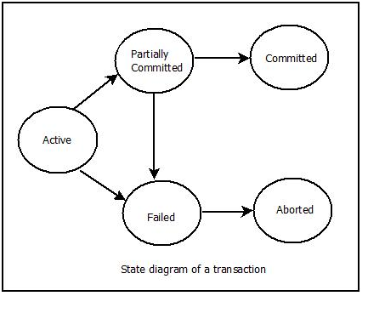

10.Schedules in which the transactions are executed non-interleaved, i.e., a serial schedule is one in which no transaction starts until a running transaction has ended are called serial schedules.

This is a type of Scheduling where the operations of multiple transactions are interleaved.

1.Select E.EmpId ,E.EName, E.EmpSal , E.Location , E.DOJ , E.JOB, E.MGRId , E.DeptID ,D.DNamefrom Employee E , Dept D where E. DeptID=D. DeptID(+);

2.Select E.EmpId ,E.EName, E.EmpSal , E.Location , E.DOJ , E.JOB, E.MGRId , E.DeptID ,D.DName from Employee E , Dept D where E.DeptID(+)=D. DeptID;

3.Select * from Employee where Location=(Select Location from Employee where EName=’Peter’);

4.select Location, sum(EmpSal) from Employee group by Location HAVING sum(EmpSal)> 10000

5.Select * from Employee where MGRId= (Select MGRId from Employee where EName=’Madhav’)

6.SELECT DEPtID, MAX(SALARY) FROM department GROUP BY DEPTID;